GLEN LAKE-CRYSTAL RIVER WATERSHED OVERLAY DISTRICT
Condensed Working Draft (with changes highlighted)
January 2022

SECTION 1 PURPOSE AND APPLICATION
- The purpose of this district is to protect the quality of water resources within the Glen Lake-Crystal River Watershed and to ensure that the structures and uses in this district are compatible with and protect these unique resources. Other specific purposes include:
  - The prevention of water pollution and water quality degradation.
  - The conservation of natural shoreland areas, forested bluffs, and ridge lines in the watershed.
  - Conservation of watershed hydrology by managing stormwater to protect the natural hydrologic regime, especially as it relates to the quantity of runoff versus infiltration and groundwater recharge.
  - Protection against the negative impacts of nutrient loading, erosion, and stormwater runoff.
- The protection of the Glen Lake-Crystal River Watershed is deemed an important public purpose in order to protect public health and welfare and to conserve natural beauty and the environmental, historical, recreational, cultural, scenic and economic attributes of the watershed and region.
- The Glen Lake-Crystal River Watershed Overlay District is a supplemental district that includes all lands located within the Glen Lake-Crystal River Watershed as depicted on the Glen Lake-Crystal River Watershed Overlay District Map. The Glen Lake-Crystal River Watershed Overlay District applies simultaneously with any of the other zoning districts established in this Ordinance, hereinafter referred to as the “underlying” zoning district. In cases where a parcel is partially inside and partially outside of the Watershed Overlay District, only those portions located within the Watershed Overlay District are required to comply with the requirements of this district.
- All other requirements shall be as required by the underlying zoning district, except that where specific requirements of the Watershed Overlay District vary or conflict with the regulations contained in the underlying zoning district, the stricter shall govern.

SECTION 2 DEFINITIONS
- For the purposes of this District, the following definitions shall apply.
  - Bluffs: Steeply sloped hills as depicted on the Glen Lake-Crystal River Watershed Steep Slope Areas Map.
  - Hardened Seawall: A seawall composed of wood, plastic, sheet piling, concrete or other hard material.
  - Lot Coverage: The part or percent of a lot occupied by impervious surfaces, including, but not limited to, buildings or structures, paving, drives, patios, and decks.
  - Low Impact Development (LID): Stormwater management practices that promote the infiltration of rainwater and recharge of groundwater (as opposed to the conveyance of stormwater off-site). The purpose of LID is to mimic a site’s pre-development hydrology by using design techniques to retain runoff close to its source. LID may include any of the following: bio-retention basins (i.e., rain gardens), infiltration trenches, porous pavement, grassed swales, perforated pipe, dry wells, rain barrels, and cisterns or other technologies or practices that reduce runoff.
  - Natural Vegetative Cover: Natural vegetation, including native species of bushes, shrubs, groundcover, and trees on a lot. Lawn shall not qualify as natural vegetative cover.
  - Ridge Line: A continuous elongated elevation of land marking or following a ridgetop as depicted on the Glen Lake-Crystal River Watershed Steep Slope Areas Map.
  - Shoreline: The ordinary high-water mark on a lot or parcel of land. On Glen Lake and Little Glen Lake, the ordinary high-water mark equates to an elevation of 596.75 feet national geodetic vertical datum (NGVD 1929).
  - Shoreline Vegetative Buffer: The land area inland from the shoreline maintained in natural or planted vegetation.
  - Steep Slopes: Lands having slopes of 12% or greater, generally composed of forested bluffs and ridge lines as depicted on the Glen Lake-Crystal River Watershed Steep Slope Areas Map. Slope is a measure of vertical rise to horizontal run. For example, land with a 12% slope has a 12-foot rise in vertical distance within 100 feet of horizontal distance.
  - Structure: Includes anything constructed or erected, which requires permanent location on the ground.

SECTION 3 DEVELOPMENT REQUIREMENTS
- Permitted Uses: With the exception of uses and activities prohibited herein, all permitted uses and special land uses permitted in the underlying zoning district shall be permitted in the Glen Lake-Crystal River Watershed Overlay District, provided such uses meet the requirements of this District.
- Non-permitted Uses: The following uses and activities are not permitted in the Watershed Overlay District:
  - Gas Stations
  - Hazardous Waste Storage Facilities
  - Salt Storage and Petroleum Storage Facilities
  - Landfills, Salvage or Junkyards
  - Industrial uses involved in the manufacturing, compounding, processing, or treating of products
  - Any other use not specifically permitted in the underlying Districts
- Lot Area, Width, Yard, Building Area, Height, and Setback Requirements
  - Minimum requirements for lot area, lot width, yards, building setbacks, building area, and building height shall conform to those required by the underlying zoning district.

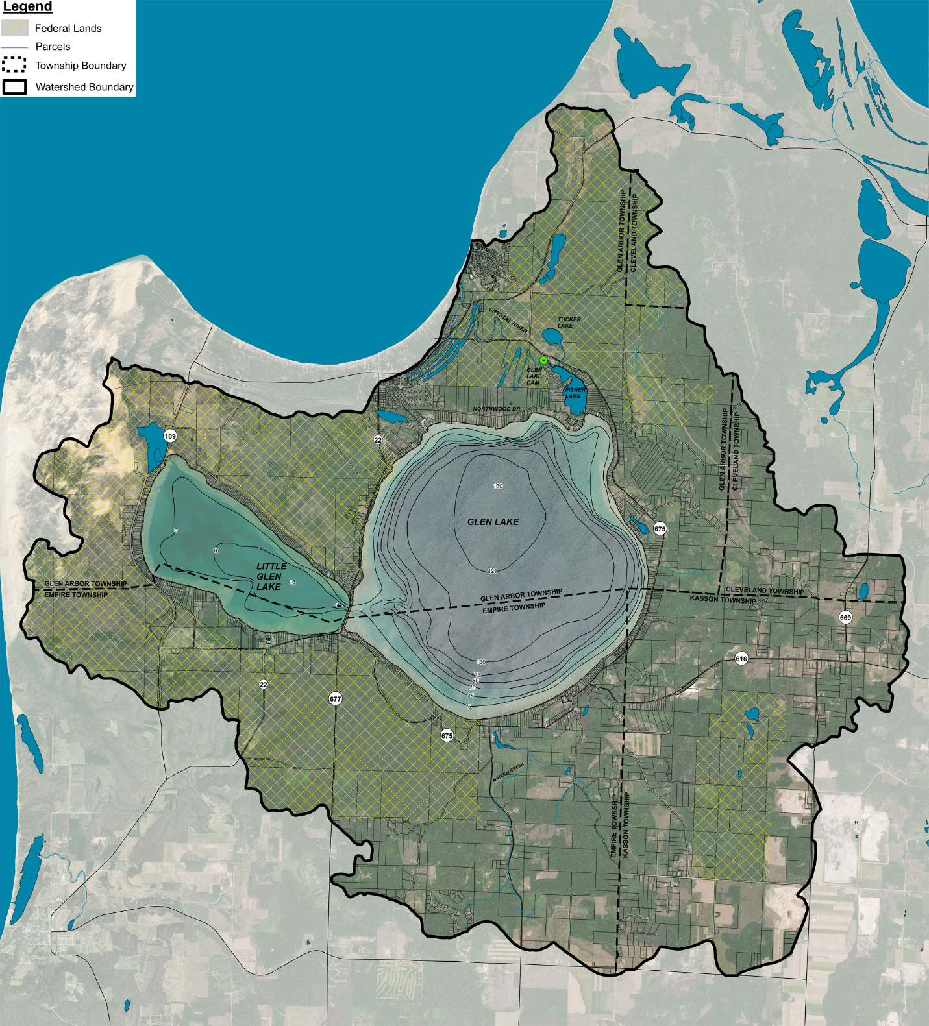
Glen Lake-Crystal River Watershed Overlay District Map.
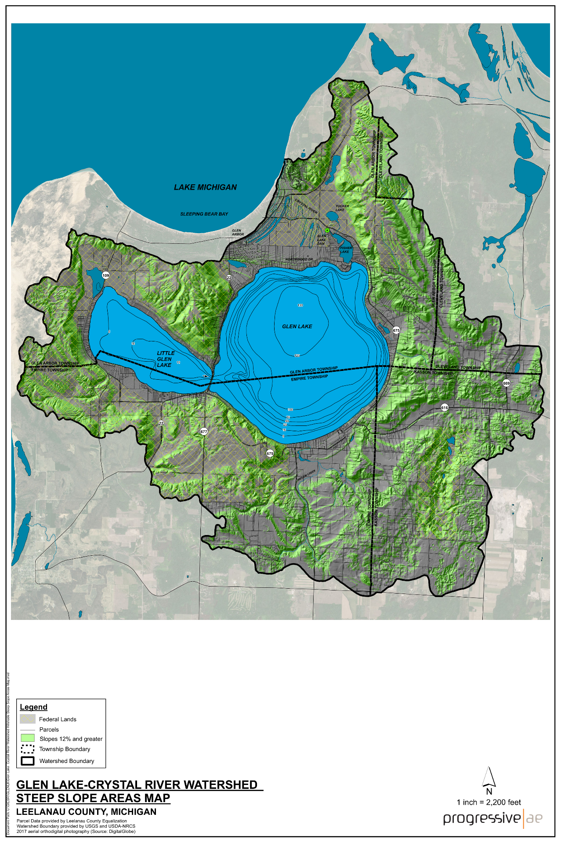
Glen Lake-Crystal River Watershed Steep Slope Areas Map

- Shoreline Vegetative Buffer
  - Intent: The purpose of the shoreline vegetative buffer is to protect the lakes and streams of the Township by preserving natural shoreline vegetative cover and habitat, preventing soil erosion, and providing a filter for the removal of pesticides, fertilizers, and other potential water pollutants.
  - A shoreline vegetative buffer bordering the lakes and rivers of the Township shall be maintained. Mowed lawn shall not qualify as natural vegetative buffer under this section. The minimum width of the buffer, as measured from the shoreline inland, shall be thirty (30) feet.
  - No more than 25% of a parcel’s shoreline lot width may be planted in turf grass and/or maintained as open sand. The other 75% pf the parcel’s shoreline lot width must be planted in native species. These native species would preferably be a mixture of forbs, shrubs, and trees. Vegetation may be removed for a single view corridor, or selective vegetation removed to provide for a filtered view throughout the shoreline, provided the cumulative total of vegetation removed does not exceed 25% of the shoreline.
  - Selective trimming of tree branches to allow for filtered views is permitted within the shoreline vegetative buffer.
  - The use of pesticides, herbicides, and fertilizers within 30 feet of the shoreline is prohibited.
  - Limited clearing of the vegetative buffer is allowed when required for construction of a permitted structure outside the vegetative buffer, provided that the land cleared is returned to a vegetative state of the same quality that existed prior to clearing and is equally effective in retarding runoff, preventing erosion, and preserving natural beauty, and the functionality of the vegetative buffer.
  - These provisions shall not apply to the removal of invasive, exotic, noxious, dead, diseased, or dying vegetation or trees that are in danger of falling, causing damage to dwellings or other structures.
  - The shoreline vegetative buffer shall not be used for any motorized vehicular traffic, parking, or for storage of junk, waste, or garbage, or for any other use not otherwise authorized by this Ordinance.
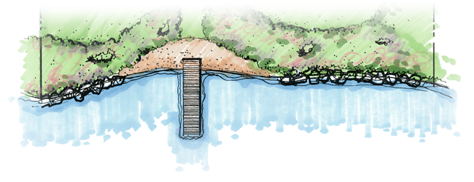
Shoreline Vegetative Buffer
Water Quality Rationale
In the first-ever National Lakes Assessment conducted by the U.S. Environmental Protection Agency and published in 2010, researchers found that lakes lacking natural shoreland habitat were three times more likely to be in poor biological condition.
In the Glen Lake-Crystal River Watershed Management Plan, it was noted that:
Riparian buffers are widely considered one of the best ways to control and reduce the amount of non-point source pollution entering a water body. Also called vegetated stream buffers, filter strips, or greenbelts, these buffers consist of strips of trees, shrubs, and other vegetation lining a stream corridor or lakefront. These linear strips of vegetation serve as a stream’s last line of defense against human activities such as lawns, septic systems, erosion and development.
Riparian buffers help to reduce the impact of almost all of the pollutants that currently threaten the Glen Lake-Crystal River Watershed: sediment, nutrients, toxins, thermal pollution, pathogens, changes to hydrology, and loss of habitat.
Recognizing the importance and value of maintaining natural shoreland areas, several states including Maine, Vermont, New Hampshire, Minnesota, and Wisconsin have enacted state-wide lake shoreland development standards. These regulations focus primarily on preservation of shoreline vegetative cover and limits on the clearing of shorelands. Local units of government in these states are required to adopt ordinances that meet the minimum state standards for water quality protection.
In accordance with Part 305 (Natural Rivers) of Michigan’s Natural Resources and Environmental Protection Act, Michigan has similar development standards for some “designated” rivers, but no state-wide standards exist for Michigan lakes. However, local planning and zoning can be an effective tool to preserve natural shoreland areas and many communities including Garfield and East Bay Townships in Grand Traverse County and Hayes Township in Charlevoix County have incorporated shoreline vegetative buffer protection standards into their zoning ordinances. Locally, the Empire Township Zoning Ordinance (Section 4.17 – Shoreline Protection Area) states that no more than one-third of trees and shrubs can be removed within 25 feet of the ordinary high-water mark while the zoning ordinances of Glen Arbor and Kasson Townships are silent on the issue. The 30-foot width of the shoreline vegetative buffer cited above would be within the 40-foot lake setback currently required in the ordinances of all three townships and would provide uniform shoreline protection standards throughout the Glen Lake-Crystal River Watershed

- Hardened Seawalls
  - Intent: To prevent or limit the construction of seawalls that cause erosion, wave deflection, increased turbidity, and prevent the natural migration of aquatic life into and out of the water.
  - Hardened seawalls are prohibited except where the applicant can demonstrate to the zoning administrator that no other practical alternative exists.

Shoreline Bioengineering
Water Quality Rationale
Most seawalls were built to help prevent erosion and stabilize the shoreline. However, there have been several unintended consequences of seawall construction:
- Seawalls deflect waves and can accelerate erosion at the foot of the seawall and nearby properties that lack seawalls.
- When a wave hits a seawall, its energy is not dissipated. Instead the wave is redirected back to the lake creating rough water conditions.
- Seawalls block the migration of frogs and other animals to shore.
In a Michigan Department of Natural Resources publication entitled Conservation Guidelines for Michigan Lakes and Associated Natural Resources, seawalls were characterized as follows:
Seawalls are detrimental to lakes in many ways. They generally remove the natural slope of the shoreline and create barriers that prevent the free migration of mammals, reptiles, and amphibians between the water and uplands. They remove the natural energy dissipating capacity of a sloped shoreline and natural vegetation, and this, in turn, causes increased erosive energy in other parts of the lake along with additional scour and deepening of the bottom and further removal of natural vegetation.
Currently, seawalls are rare on Glen and Little Glen Lakes. Many of the problems associated with seawalls can be addressed by using more natural, bioengineering approaches. Bioengineering uses a combination of native plantings and natural or biodegradable materials to engineer shoreline protection that, to the extent practical, mimics and or enhances the natural landscape. Seawall construction at or below the ordinary high-water mark requires a permit in accordance with Part 301 (Inland Lakes and Streams) of Michigan’s Natural Resources and Environmental Protection Act. Recognizing the problems with conventional seawalls, the Michigan Department of Environment, Great Lakes and Energy has created an expedited minor permit category to incentivize bioengineering approaches.
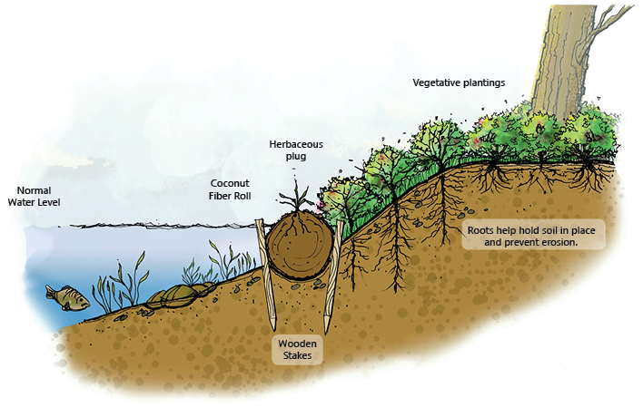

- Fertilizer Use
  - Intent: To limit the use of phosphorus-laden lawn fertilizers that accelerate lake eutrophication.
  - Consistent with state law, lawn fertilizer containing phosphorus shall not be applied unless a new lawn is being established or a soil test documents a phosphorus deficiency. Agricultural fertilizer applications are exempt from this requirement.
Water Quality Rationale
Phosphorus is the nutrient that most often stimulates excessive growth of aquatic plants, leading to a variety of problems known collectively as eutrophication. Elevated phosphorus levels are causing premature aging of many Michigan lakes.
To address this problem, Michigan passed legislation several years ago that limited the phosphorus content of laundry detergents and more recently extended the ban to dishwater detergents. However, phosphorus in fertilizers remained a problem. Phosphorus is a key ingredient in many commercial lawn fertilizers and is commonly applied at rates well in excess of what is needed to maintain a healthy lawn. Excess phosphorus can run off into lakes and streams where a single pound of phosphorus can generate hundreds of pounds of aquatic vegetation.
Michigan recently joined several other Great Lakes states in banning phosphorus in lawn fertilizers. The new law, which took effect on January 1, 2012, prohibits the application of lawn fertilizers containing phosphorus unless a new lawn is being established (and phosphorus is needed to promote root growth) or if a soil test indicates a soil phosphorus deficiency. The new law also regulates the application of lawn fertilizer near surface waters and prohibits lawn fertilizer applications on frozen ground or ground saturated with water.
Under the new law, fertilizer containing phosphorus can be applied on golf courses operated by staff members that have been certified by the Department of Agriculture as having completed training on best management practices for the proper use of phosphorus fertilizers.
Agricultural fertilizer applications are exempt from regulation under the new law, as are phosphorus applications for gardens, trees, and shrubs.

- Lot Coverage and Natural Vegetative Cover
  - Intent: To minimize impervious surfaces and runoff and promote the natural infiltration and recharge of groundwater in the watershed.
  - For all development in the Glen Lake-Crystal River Watershed, excluding commercial, industrial, agriculture and gravel mining operations, the following Lot Coverage and Natural Vegetative Cover provisions shall apply:
    - Lot Coverage: The maximum lot coverage shall not exceed 25% of the entire lot area. The use of pervious pavement for driveways and patios is encouraged and may be excluded from the calculation of lot coverage.
    - Natural Vegetative Cover: Lots shall maintain a minimum of thirty percent (30%) of the entire lot area in natural vegetative cover. To the extent practical, Natural vegetative cover shall be maintained along lot lines, natural drainage courses, and wetlands. On lots bordering lakes, the Shoreline Vegetative Buffer required by this District may be included as part of the Natural Vegetative Cover. The select trimming of branches to afford views is permitted within areas of natural vegetative cover. This provision shall not apply to the removal of invasive, exotic, noxious, dead, diseased, or dying vegetation or trees that are in danger of falling, causing damage to dwellings or other structures. Limited clearing of natural vegetative cover is allowed when required for construction of a permitted structure outside the area of natural vegetative cover, provided that the land cleared is returned to a vegetative state of the same quality that existed prior to clearing and is equally effective in retarding runoff, preventing erosion, and the functionality of natural vegetative cover.
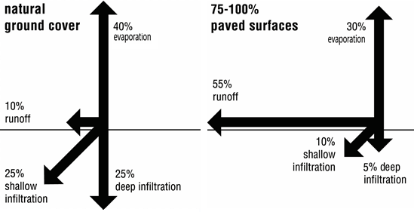
    - In the case of planned unit developments, site condominiums, and open space developments, each individual lot need not meet the requirements of this Section, provided that the total project or an individual phase of a project meets the requirements of this Section.
Water Quality Rationale
Typically, as development occurs within a watershed, forested areas are replaced by impervious surfaces such as roads, driveways and roof tops. As overall imperviousness increases, runoff increases and the amount of water infiltrating to groundwater decreases. Steep slopes, as are common in the Glen Lake-Crystal River Watershed, exacerbate this potential.
Runoff often contains oil and gasoline residues, nutrients, sediment, oxygen-consuming wastes, and a variety of other contaminants that can degrade water resources. In fact, the Center for Watershed Protection reported that adverse water quality and hydrologic impacts have been observed in watersheds with as little as 10% imperviousness. Minimizing imperviousness is an important consideration in watershed management.
The overlay district provisions are intended to strike a balance between the amount of imperviousness and natural vegetative cover as additional development occurs in the watershed. The provisions may also help to address the “big foot” phenomena in which oversized houses dominate small lots.
- Stormwater Management
  - Intent: This provision is intended to preserve natural drainage systems to encourage infiltration and to minimize the need to construct enclosed, below-grade storm drain systems; to preserve natural infiltration and the recharge of groundwater and to maintain subsurface flows which replenish lakes, streams, and wetlands and maintain water quality; and to ensure that soil erosion, sediment, and stormwater runoff control systems are incorporated into site planning at an early stage in the planning and design process.
  - As of the effective date of this Ordinance, stormwater shall be managed in accordance with low impact development (LID) design principles that promote the infiltration of rainwater and recharge of groundwater (as opposed to the conveyance of stormwater off-site). Where feasible, steps shall be taken to retain and infiltrate stormwater on-site via LID practices. All lots shall retain stormwater runoff on-site or detain it so as to allow discharge without any impact on adjacent lands, streams or water bodies beyond the existing predevelopment runoff impact.
  - Lands within the Glen Lake-Crystal River Watershed are deemed environmentally sensitive areas having a high potential for environmental degradation as a result of soil erosion and stormwater runoff and are thus subject to the standards contained within Leelanau County’s Soil Erosion, Sedimentation and Stormwater Runoff Control Ordinance. On all lands within the watershed, a land use or building permit shall not be granted until a permit or waiver has been issued by the Leelanau County Enforcing Agency (i.e., the Leelanau Conservation District) in accordance with the Leelanau County Soil Erosion, Sedimentation and Stormwater Runoff Control Ordinance.

Bio-retention (Rain Garden)
Water Quality Rationale
The largest source of water to Glen Lake and Little Glen Lakes is groundwater. In the Glen Lake-Crystal River Watershed Management Plan it was noted:
Groundwater is an extremely important factor in the hydrological budget of Glen Lake. Therefore, it is essential that groundwater is replenished or “recharged.” This underscores the importance of protecting upland areas from impervious surfaces or other development that can inhibit the percolation of precipitation through the soil into the groundwater and decrease groundwater recharge…
Maintaining the natural hydrologic balance in the Glen Lake-Crystal River Watershed is essential to sustaining water quality. One way to preserve the natural balance is by using planning and zoning tools that promote low impact development (LID) design principles. The purpose of LID is to mimic a site’s pre-development hydrology by using design techniques to retain runoff close to its source. Essentially, rainwater is managed where it falls. LID still allows land to be developed, but in a cost-effective manner that helps mitigate potential environmental impacts. The highly-permeable soils throughout the Glen Lake-Crystal River Watershed provide opportunities to implement LID in that, in many cases, stormwater can be infiltrated and retained on-site.
Without proper stormwater management, build-out of the Glen Lake-Crystal River Watershed could degrade water quality. Low impact development would minimize potential water quality impacts. The stormwater management provision of the watershed overlay district would help to ensure stormwater management issues are addressed as part of the development approval process.

- Steep Slopes
  - Intent: The steep slope standards are intended to preserve the environmental attributes of the forested bluffs and ridge lines in the watershed and to minimize the potential for soil erosion and sedimentation.
  - Access drives and/or roads shall be placed as close to the natural contour of the land as possible in order to minimize cutting and filling.
  - Natural Vegetative Cover: To the extent practical, natural vegetative cover shall be maintained along lot lines, natural drainage courses, ridge lines and bluff tops. Within the area of Natural Vegetative Cover, vegetation removal shall be restricted to the removal of dead, diseased, or dying trees. All removal of vegetation shall be done in such a manner as to avoid erosion. The select trimming of branches to afford views is permitted within areas of natural vegetative cover. Developers of steep sloped areas may be required to provide an alternatives analysis to determine if impacts to ridge lines and bluff tops can be avoided or minimized.
  - No pathway or trail shall cause erosion or damage to non-vegetated or vegetated areas. The zoning administrator may require raised boardwalks or stairways be erected to prevent weakening or damaging of the steep slope area.
Water Quality Rationale
Steeply sloped bluffs and ridge lines help to define the unique character of the Glen Lake-Crystal River Watershed. For the most part, the bluffs and ridge lines in the watershed remain forested; many are located within the Sleeping Bear Dunes National Lakeshore and, thus, are permanently protected. However, several steeply sloped bluffs and ridges exist on lands under township zoning jurisdiction. Some of these bluffs and ridges are several hundred feet above the elevation of the lakes in the watershed and are prominent natural features that define the landscape.
In general, the higher and steeper the bluff, the greater the potential for problems if improperly developed. The steep slope standards are designed to help prevent unreasonable alteration of the forested bluffs and ridge lines in the watershed and to reduce the potential for erosion. The Glen Lake-Crystal River Watershed Steep Slope Areas Map depicts the generalized location of steeply sloped areas within the watershed; it can be used to identify lands and parcels in which the steep slope provisions of the watershed overlay district apply.

- General Design and Development Standards
  - Intent: The general design and development standards are intended to minimize the impact of development on the land and water resources of the watershed.
  - Natural vegetation shall be maintained wherever possible.
  - Existing mature trees shall be maintained on site where feasible. The developer must demonstrate how trees will be protected during construction or how to relocate trees if necessary.
  - To the extent feasible, natural drainage areas shall be protected from grading activity. Where possible, existing natural runoff control features such as swales, berms, and shallow depressions shall be retained to help reduce runoff and to encourage infiltration of stormwater.
  - Grading shall be conducted to minimize undue compaction of site soils.
  - Buildings and structures shall be clustered as much as possible to retain open space and surrounding tree cover, and to minimize changes in topography.
  - Clearing of land is prohibited without appropriate approval from the Township except when land is cleared and cultivated for an agricultural, forestry, or garden use in a district permitting such use.
  - The smallest practical area may be exposed at any one time during development. When land is exposed during development, the exposure shall be kept to the shortest practical period of time.
  - Where feasible, private roads and driveways shall be located along natural contours in order to minimize cutting and filling and the potential for erosion.
  - Appropriate measures shall be taken to prevent adverse impacts to neighboring properties or the quality of area water resources from stormwater drainage.
  - Low Impact Development (LID) shall be used where practical and, to the extent feasible, stormwater shall be retained on-site.
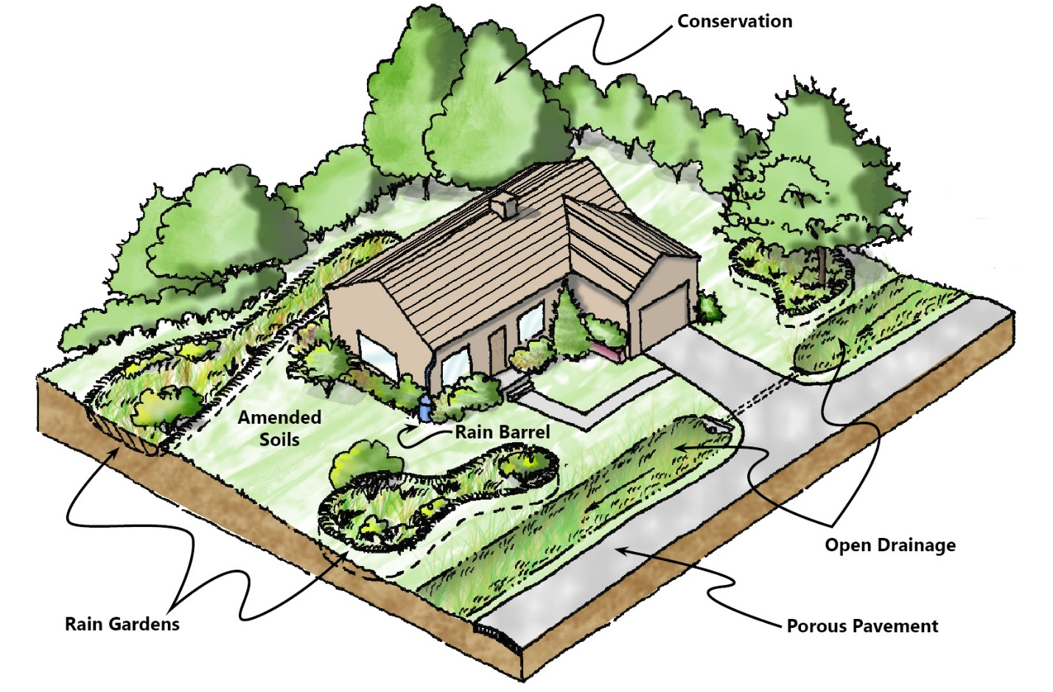
Low Impact Development—Site Level

SECTION 4 APPROVALS
- Intent: To provide a process that requires all development within the Glen Lake-Crystal River Watershed to be reviewed to ensure full compliance with requirements of this District.
- Site plan approval, in accordance with the requirements of the Site Plan Review provisions of the Township, shall be obtained for development subject to the Township’s site plan review standards. For parcels in the Glen Lake-Crystal River Watershed subject to the Township’s site plan review standards, site plans shall include all information required for site plan review as well as the following:
- Existing natural features such as mature trees, wetlands, steep slopes, soil types, drainage and water features, and a narrative description of how natural areas will be preserved.
- The ordinary high-water mark and proposed shoreline vegetative buffer (if applicable).
- The placement of proposed structures; grading limits; areas where vegetation is proposed to be cleared and areas where natural vegetative cover is proposed to be preserved.
- A calculation of the percent Lot Cover and percent Natural Vegetative Cover.
- Existing structures on the subject property.
- Low impact development stormwater management controls proposed to be used on the site.
- For development in the Glen Lake-Crystal River Watershed not subject to site plan review, a plot plan drawn to scale meeting the requirements of Section 4.B above must be submitted to the Township’s zoning administrator for administrative review and approval prior to the issuance of a building permit.
- Development within the Watershed Overlay District must conform with all applicable County, State, Federal, and Township statutes and ordinances including, but not limited to, the Leelanau County Soil Erosion, Sedimentation and Stormwater Runoff Control Ordinance, Part 301 (Inland Lakes and Streams) of the Natural Resources and Environmental Protection Act and septic and well approvals from the Benzie-Leelanau District Health Department.
Water Quality Rationale
The Michigan Zoning Enabling Act (PA 110 of 2006) defines a Site Plan as follows: “Site plan" includes the documents and drawings required by the zoning ordinance to ensure that a proposed land use or activity is in compliance with local ordinances and state and federal statutes. Under the zoning enabling act, a site plan is required for all special uses and planned unit developments. Many communities require site plan review for commercial and industrial development as well. Beyond the statutory requirements for site plan review, communities have discretion to decide which types of development require review and the level of review.
In the publication entitled Protecting Michigan’s Inland Lakes – A Guide for Local Governments, site plans are described as follows:
Site plans are the documents and drawings that present information showing what an applicant for zoning approval wants to achieve on a parcel of land. Because good site plans usually include information on stormwater patterns, topography, soils and wetland locations, they can help local decision makers better assess what might be necessary to protect water resources before construction begins.
Site plan review provides an effective mechanism to protect water quality by ensuring water quality protection issues are addressed as part of the development design process. The Approval section of the overlay district would require that provisions of the Glen Lake-Crystal River Watershed Overlay District be considered as part of the development review process and that all development that is not currently subject to site plan review be subject to an administrative review by the zoning administrator prior to the issuance of a land use or building permit.

