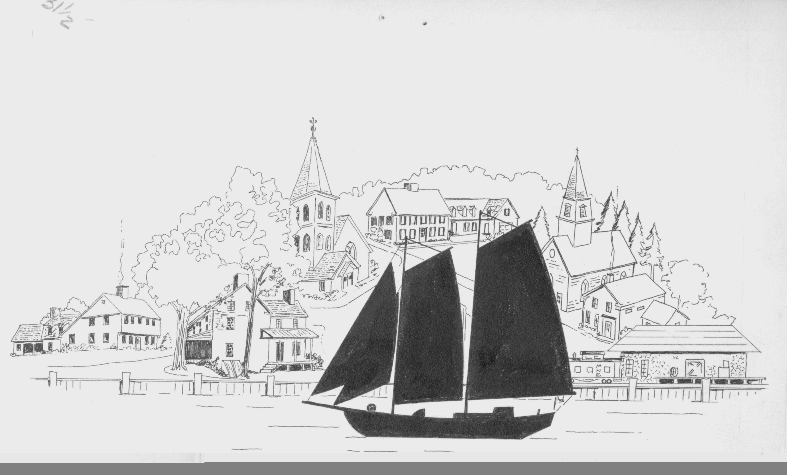Village of Northport 116 W.Nagonaba - P.O.Box 336 - Northport, MI 49670 - (231) 386-5182 - FAX (231) 386-5184

WAITING LIST APPLICATION
NORTHPORT MARINA

THIS DATE OF: APPLICATION & $25.00 PAYMENT RECEIVED BY THE VILLAGE OF NORTHPORT & APPLICANT PLACED ON THE APPROPRIATE WAITNG LIST.

Applicant requests to be placed on the Waiting List for a Seasonal Slip:

32 foot Waiting List ;
42 foot Waiting List ;
60 foot Waiting List ;

[Each Waiting List (checked) requires a $25.00 Non-refundable Payment]

APPLICANT:

ADDRESS:

TELEPHONE:

- This Initial Application for the above (checked) Waiting List for a Seasonal Slip must be completed by the Applicant & returned to the Village of Northport with Payment of $25.00 Payable to the Village of Northport. Each Waiting List checked requires a $25.00 Payment

- The Payment is Non-refundable; and the Date when both the Application & Payment is received is the date that Applicant is placed on the Waiting List

- Any Seasonal Slips that become available will be offered to the Applicant at the top of the appropriate Waiting List. If the applicant declines a slip that becomes available but wishes to stay on the list, that applicant shall remain there until the following season but if declined a second time will be returned to the bottom of the list for that particular size.
- Any or all questions or concerns should be directed to Mark Holtz, Harbor for the Village of Northport. Office (231)386-5411.

